CPE301 – SPRING 2019

MIDTERM I

Student Name: Rocky Yasuaki Gonzalez

Student #: 5003229733

Student Email: gonzar14@unlv.nevada.edu

Primary Github address: https://github.com/rockyg1995/ihswppdar

Directory: https://github.com/rockyg1995/ihswppdar/tree/master/Midterms/Midterm_I

Submit the following for all Labs:

1. In the document, for each task submit the modified or included code (only) with highlights and justifications of the modifications. Also, include the comments.
2. Use the previously create a Github repository with a random name (no CPE/301, Lastname, Firstname). Place all labs under the root folder ESD301/Midterm, sub-folder named LABXX, with one document and one video link file for each lab, place modified asm/c files named as LabXX-TYY.asm/c.
3. If multiple asm/c files or other libraries are used, create a folder LabXX-TYY and place these files inside the folder.
4. The folder should have a) Word document (see template), b) source code file(s) and other include files, c) text file with youtube video links (see template).

1. **COMPONENTS LIST AND CONNECTION BLOCK DIAGRAM w/ PINS**

Atmega328PB Xplained Mini

Micro USB Cable (Power Supply)

Wire Connectors

LM35

ESP01

1. **INITIAL/MODIFIED/DEVELOPED CODE**

/*

* MIDTERM_I.c

*

* Created: 4/7/2019 11:11:38 PM

* Author: rocky

*/

#define *F_CPU* 16000000UL // Frequency of Xplained Mini (16MHz)

#include <avr/io.h> // Standard AVR Library

#include <stdio.h> // AVR library containing printf functions

#include <avr/interrupt.h> // AVR library containing interrupt functions

#include <util/delay.h> // AVR library containing _delay_ms() function

#define BAUDRATE 115200 // Baudrate in Bits per second (bps)

#define BAUD_PRESCALLER ((*F_CPU* / (BAUDRATE * 16UL)) - 1) // Baudrate Prescaler

#define MAX_1s 15624 // 1s delay: OCR1A = (16MHz*1000ms/prescaler) -1

//Declaration of our functions

void Timer1_init(void); // Function to initialize Timer1

void USART_init(void); // Function to initialize USART

void adc_init(void); // Function to initialize Analog to Digital Converter

unsigned char USART_receive(void); // Function to receive Serial data from UDR0

void USART_send(unsigned char data); // Function to send char data into UDR0

void USART_putstring(char* StringPtr); // Function to break string into chars and send

void read_adc(void); // Function to read temp received from ADC

volatile float adc_temp; // Stores ADC Value representing Temperature

char outs[20]; // 'outs[]' to store values into array of chars

int main(void) {

DDRD = 0b00000010; // Main Importance: PD0/RX Input, PD1/TX Output

TIMSK1 |= (1 << OCIE1A); // Set Interrupt on Compare Match

sei(); // Enable Global Interrupts

Timer1_init(); // Call the Timer1 initialization code

USART_init(); // Call the USART initialization code

adc_init(); // Call the ADC initialization code

USART_putstring("Connected!\r\n"); // Pass 'Connected!' to function to send chars

*_delay_ms*(125); // Wait a bit

float adc_tempf; // to store ADC Fahrenheit Temperature

USART_putstring("AT+CWJAP=\"WIFI_NAME_HERE\",\"WIFI_PASSWORD_HERE\"");//Login WiFi

while (1) { // Infinite loop

if (TCNT1 == OCR1A) { // Display a String when Timer1 Matches OCR1A

read_adc(); // Read value of ADC Temperature

adc_tempf = (ADCH << 8) + ADCL; // T(C)=Vout/10mV, TOS=ADC - T(C)

adc_tempf = (9/5)*adc_tempf + 32; // Converts Celsius to Fahrenheit

*snprintf*(outs,sizeof(outs),"%3f\r\n", adc_tempf);// Stores integer

// 'adc_temp' in string 'outs'

USART_putstring("AT+CIPSTART=\"TCP\",\"api.thingspeak.com\",80"); // Connect API KEy

USART_putstring("AT+CIPSEND=51"); // Send Serial Data

USART_putstring("GET /update?key=YR8DHQMB2YJS3AAX&field1=outs\r\n"); // Send Value

USART_putstring("AT+CIPCLOSE"); // Close Data

}

}

return 0;

}

//-----------------------------------------------------------------------

void Timer1_init(void) { // Function to Initialize Timer1 properties

OCR1A = MAX_1s; // Let the OCR1A be the Max Value used for 1s delay

TCCR1A = (0<<COM1A1)|(0<<COM1A0); // Normal Operation, Disconnected OC1A COM1A1:0

TCCR1A = (0<<COM1B1)|(0<<COM1B0); // Normal Operation, Disconnected OC1B COM1B1:0

TCCR1A = (0<<WGM11)|(0<<WGM10); // Set Timer1 to CTC Mode 'WGM1:0'

TCCR1B = (0<<WGM13)|(1<<WGM12); // Set Timer1 to CTC Mode 'WGM3:2'

TCCR1B = (1<<CS12)|(0<<CS11)|(1<<CS10); // Set Clock Select for Prescaler '1024'

}

ISR(TIMER1_COMPA_vect) { // Function to Truncate Timer1 to delay properly for 1 second

TCNT1 = 0; // Restart Timer1 from the Beginning

return; // Resume code from where interrupt left off

}

//-----------------------------------------------------------------------

void USART_init(void) { // Function to Initialize USART properties

UBRR0H = (*uint8_t*)(BAUD_PRESCALLER >> 8); // Store Upper Baudrate values in UBRR0H

UBRR0L = (*uint8_t*)(BAUD_PRESCALLER); // Store Lower Baudrate values in UBRR0L

UCSR0B = (1 << RXEN0) | (1 << TXEN0); // Enable Receiver and Enable Transmitter

UCSR0C = (3 << UCSZ00); // Set UCSZ02:1 as 8-bit character data

}

unsigned char USART_receive(void) { // Function to receive ASCII value from UDR0

while (!(UCSR0A & (1 << RXC0))); // Checking until RXC0 is 'High' to break loop

return UDR0; // Return received serial into char data

}

void USART_send(unsigned char data) { // Function to transmit ASCII value into UDR0

while (!(UCSR0A & (1 << UDRE0))); // Check until UDRE0 'High' to break loop

UDR0 = data; // Store unsigned char serial data into UDR0

}

void USART_putstring(char* StringPtr) { // break string into chars, then USART_send()

while (*StringPtr != 0x00) { // Looping until String Completed (null/0-bits)

USART_send(*StringPtr); // Send char value pointed by the string pointer

StringPtr++; // Increment pointer to next char array location

}

}

//-----------------------------------------------------------------------

void adc_init(void) {

ADMUX = (0<<REFS1)|(1<<REFS0)| // Reference Selection Bits, AVcc Ext cap AREF

(0<<ADLAR)| // ADC Left Adjust Result

(0<<MUX3)|(1<<MUX2)|(0<<MUX1)|(1<<MUX0); // Analog Channel Select Bits 'ADC5'

ADCSRA = (1<<ADEN)| // ADC Enable

(0<<ADSC)| // ADC Start Conversion

(0<<ADATE)| // ADC Auto Trigger Enable

(0<<ADIF)| // ADC Interrupt Flag

(0<<ADIE)| // ADC Interrupt Enable

(1<<ADPS2)|(0<<ADPS1)|(1<<ADPS0); // ADC Prescaler Select Bits '32'

}

void read_adc(void) {

unsigned char i = 4; // Set 'i' for iterations

adc_temp = 0; // set float 'adc_temp'

while (i--) { // Decrement 'i' until 4 samples take

ADCSRA |= (1<<ADSC); // If ADSC is high (ADC Start Conversion)

while (ADCSRA & (1<<ADSC)); // Start the ADC Conversion

adc_temp += ADC; // Store analog value of current adc_temp

*_delay_ms*(50); // delay 50ms for sampling

}

adc_temp = (adc_temp/4); // Average 4 samples taken into adc_temp

}

1. **SCHEMATICS**

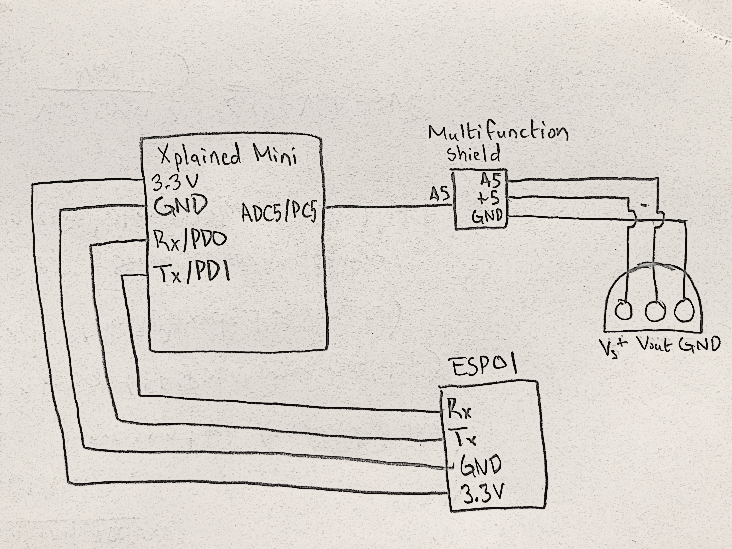

*Figure 1 – Schematic Setup of ESP01 Module*

1. **SCREENSHOTS OF EACH TASK OUTPUT (ATMEL STUDIO OUTPUT)**

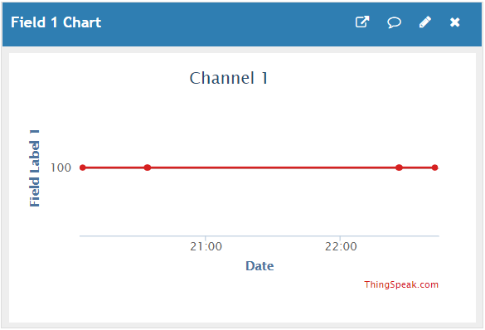

*Figure 2 – Output through ThingSpeak Temperature Reading*

1. **SCREENSHOT OF EACH DEMO (BOARD SETUP)**

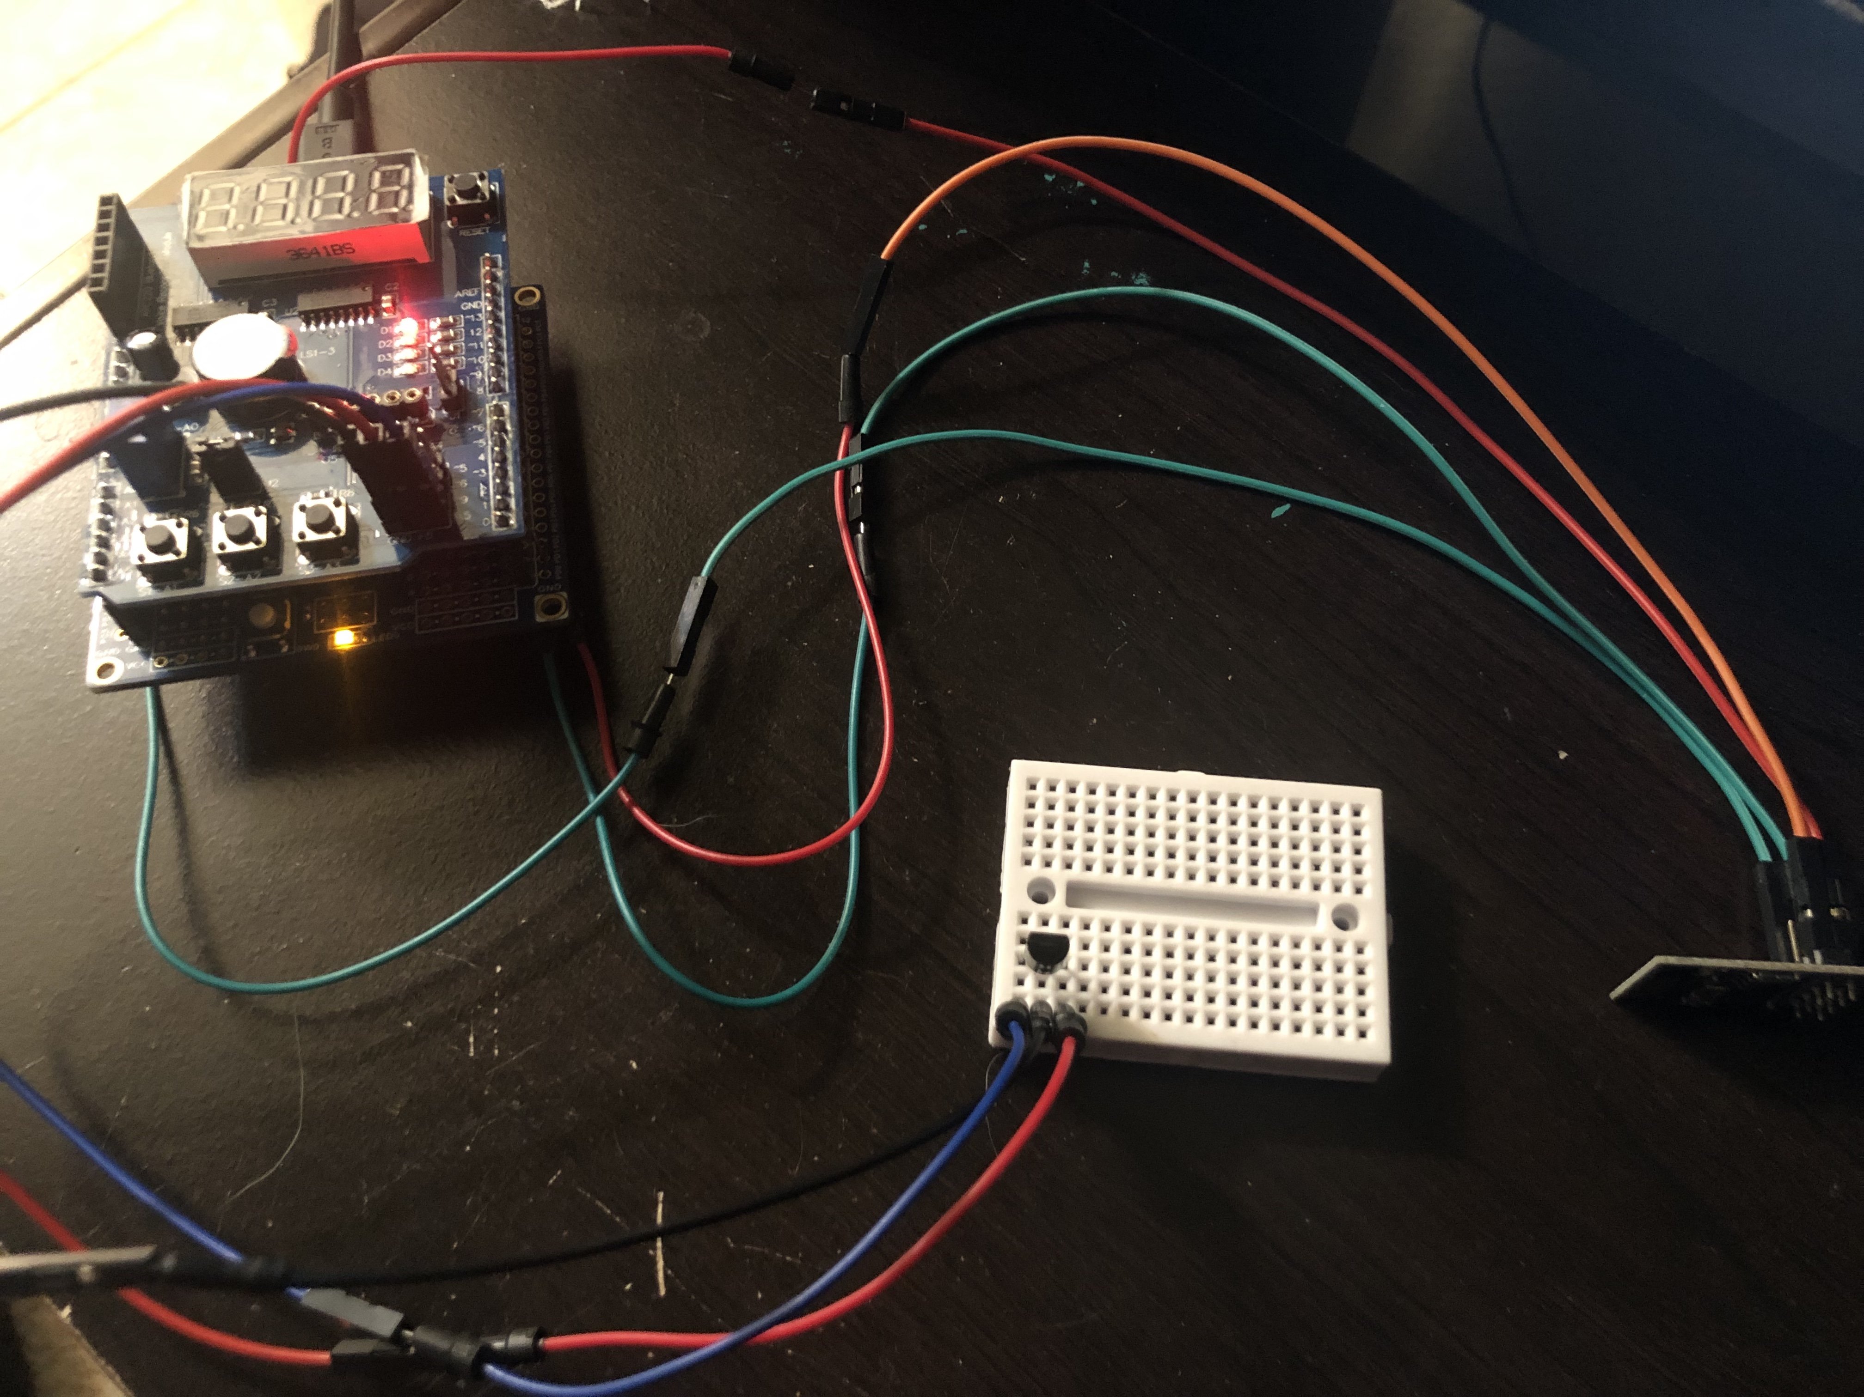

*Figure 3 – Board Setup for ESP01 Modul and Atmega328PB w/ Temperature Sensor*

1. **VIDEO LINKS OF EACH DEMO**

N/A

1. **GITHUB LINK OF THIS DA**

https://github.com/rockyg1995/ihswppdar/tree/master/Midterms/Midterm_I

**Student Academic Misconduct Policy**

<http://studentconduct.unlv.edu/misconduct/policy.html>

“This assignment submission is my own, original work”.

Rocky Yasuaki Gonzalez